*User Guide Document*

*Project Title*

***Vinegar-food***

*Supervisor*

***Muhammad Hamza***

|  |  |  |
| --- | --- | --- |
| **Batch** | 2409C1 | |
| **Group** | **D** | |
| **Serial No.** | **Enrollment Number** | **Students Name** |
| 1. | Student1600657 | Syed Muhammad Faisal |
| 2. | Student1605847 | Muhammad Saad Anwar Malick |
| 3. | Student1600656 | Abdul Rehman |
| 4. | Student1605835 | Hisban Shahzad |
| 5. | Student1608421 | Taha |

**Group Details**

HOME: (index.html)

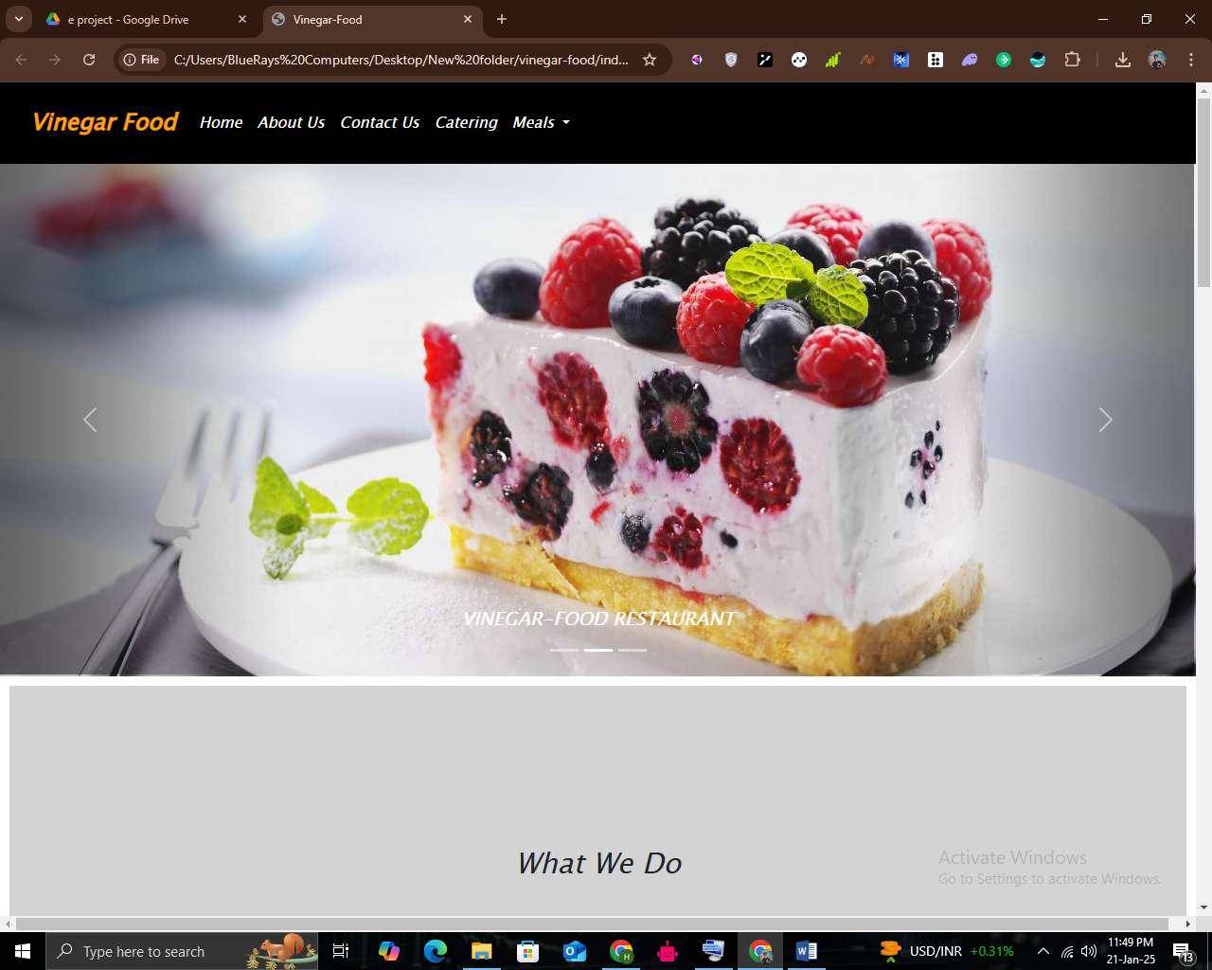

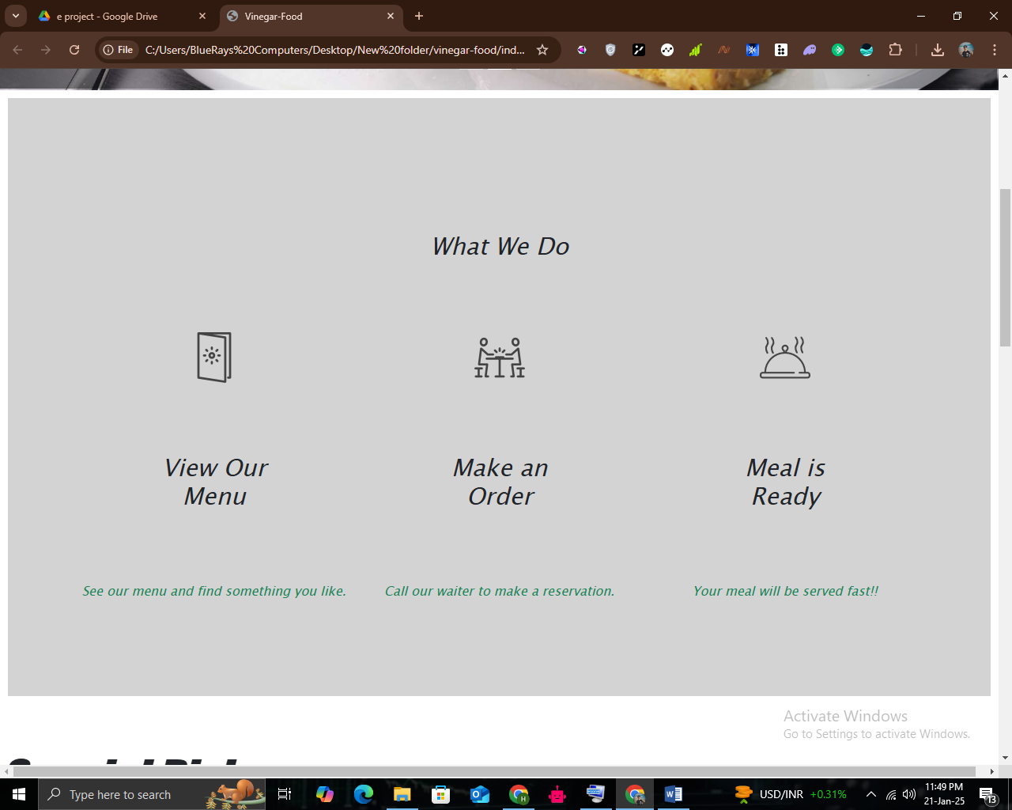

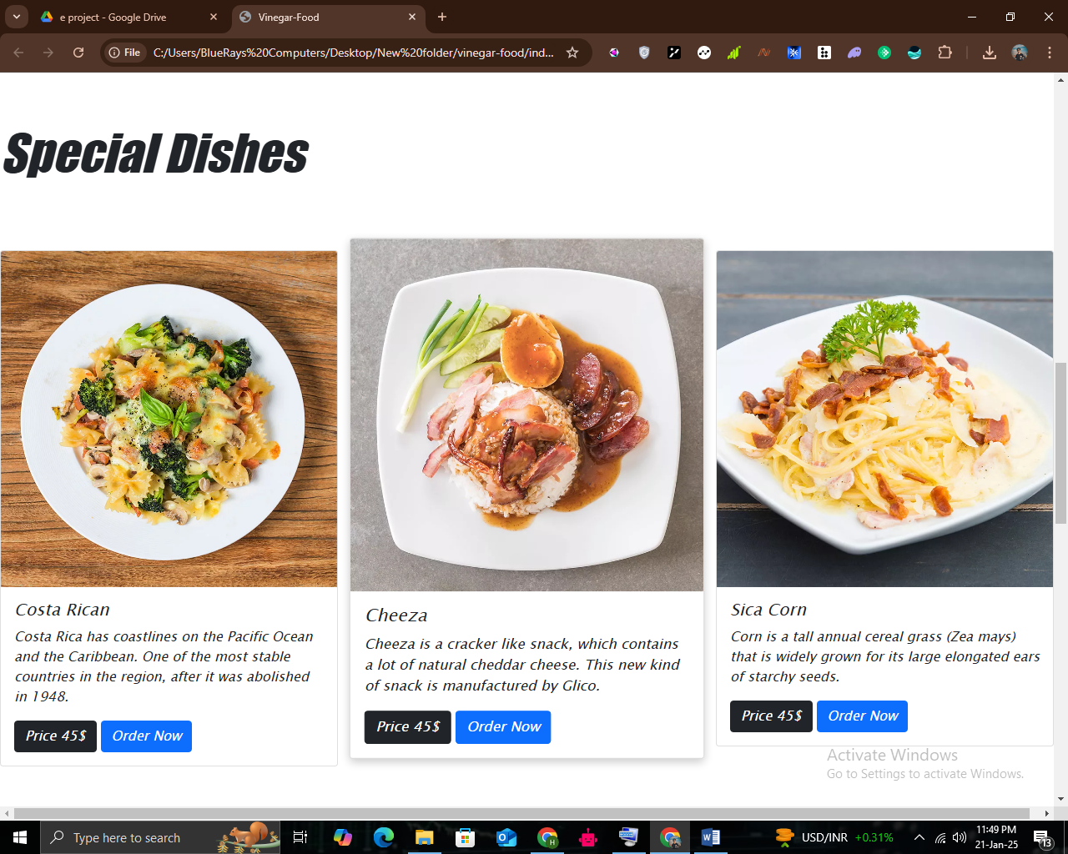

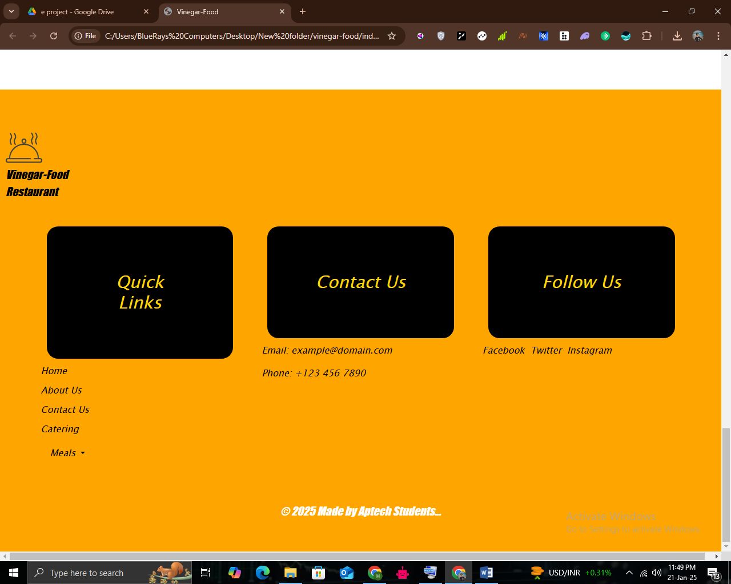

ABOUT US: (about.html)

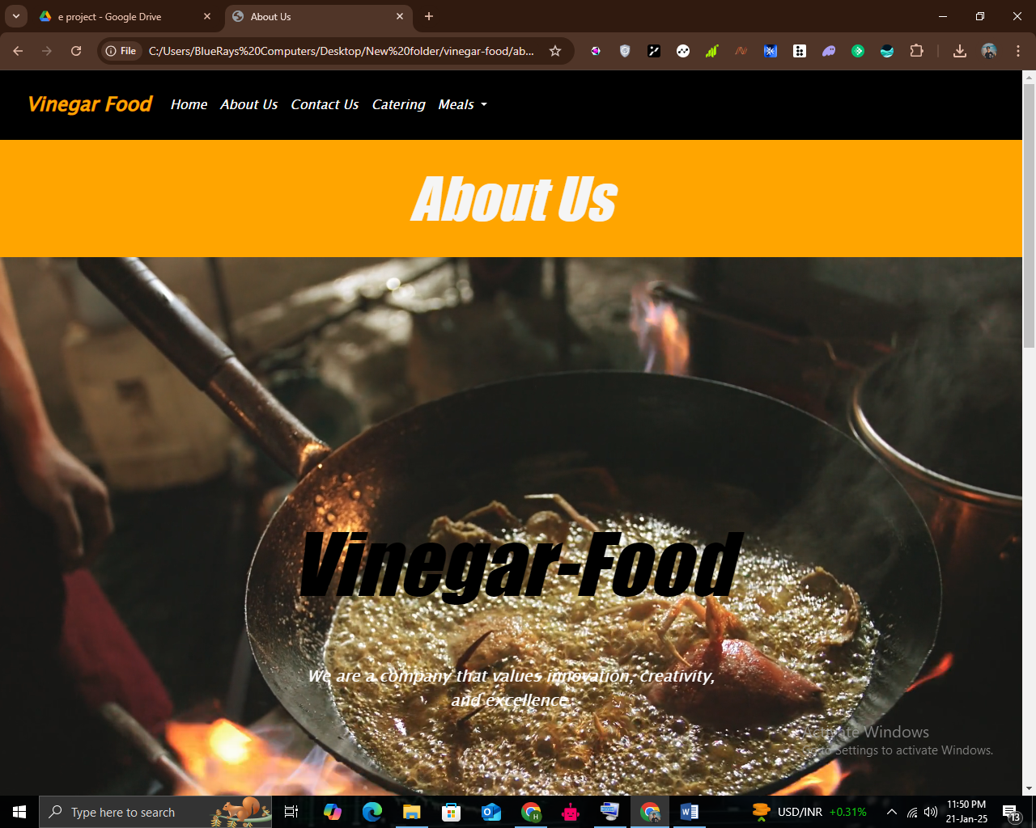

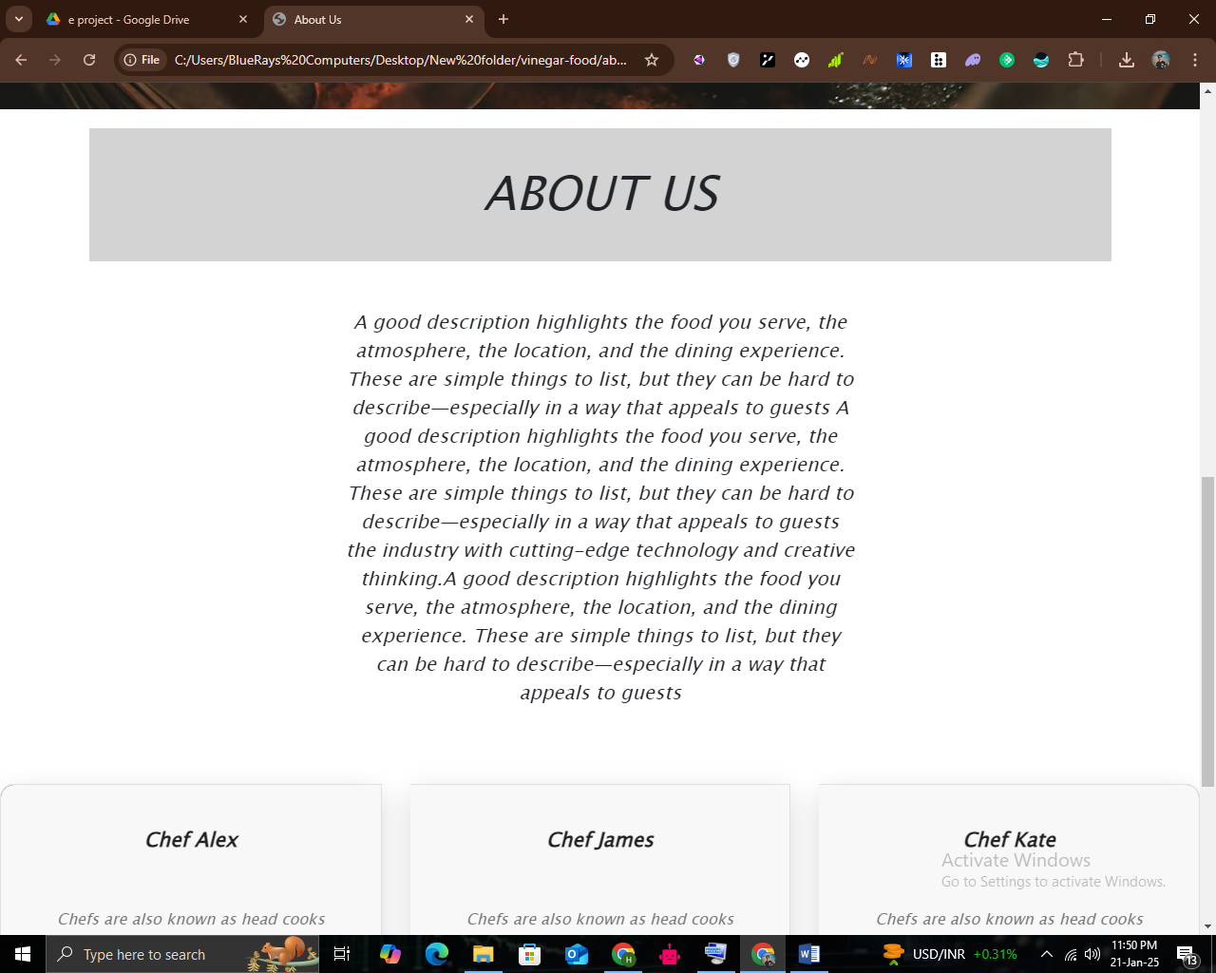

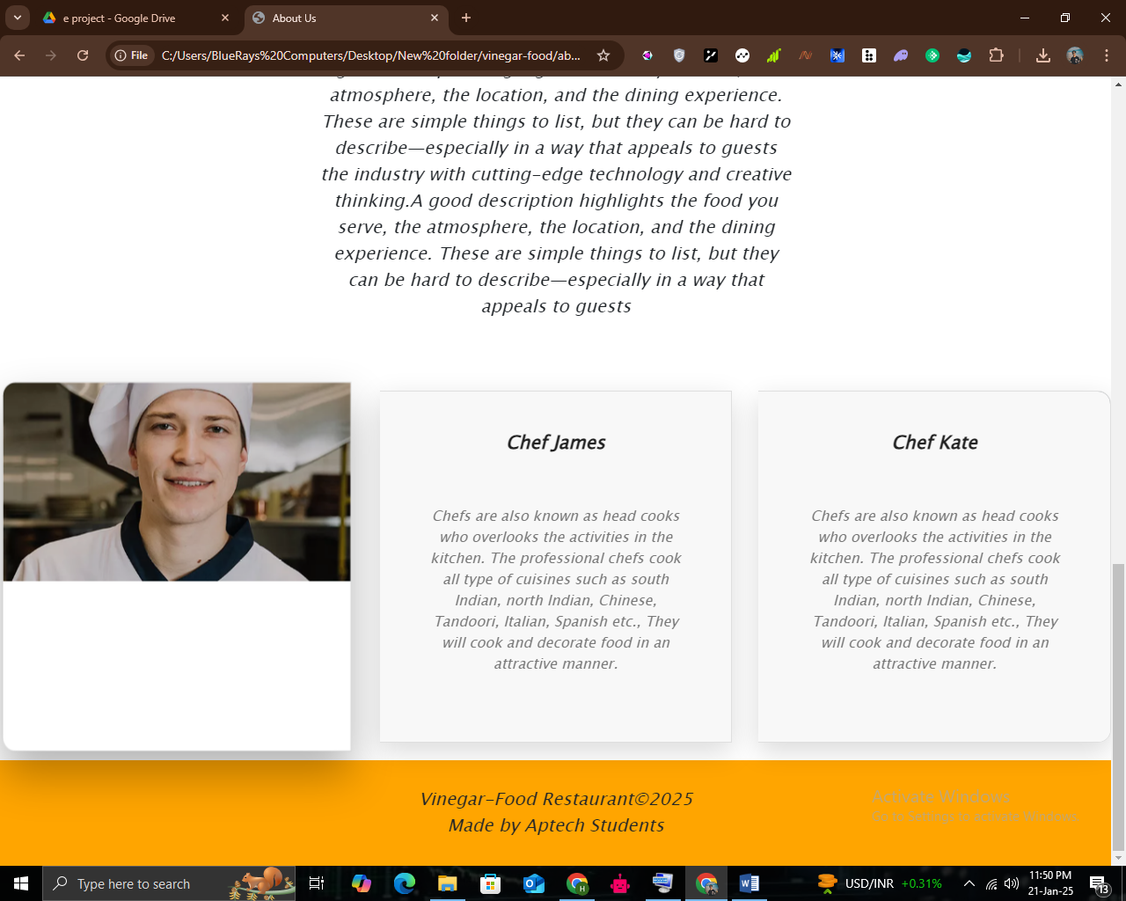

CONTACT US (contact.html)

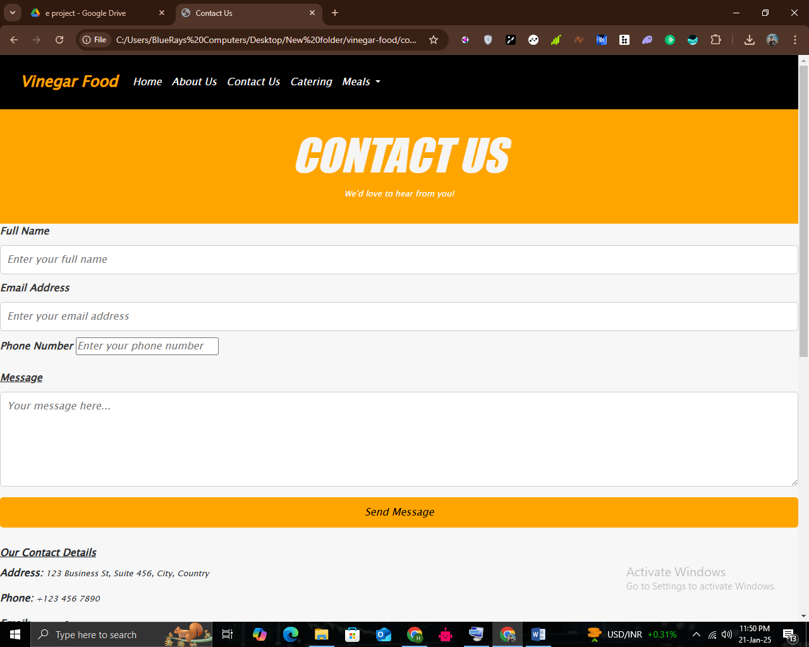

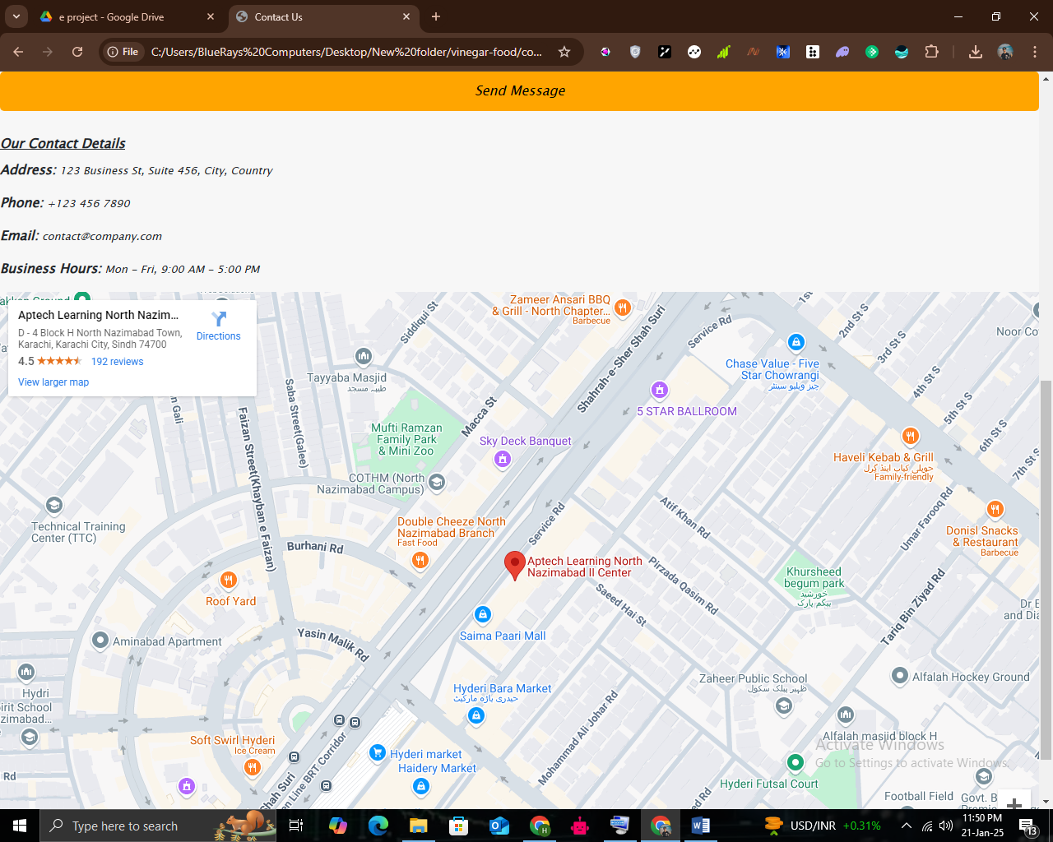

CATERING: (catering.html)

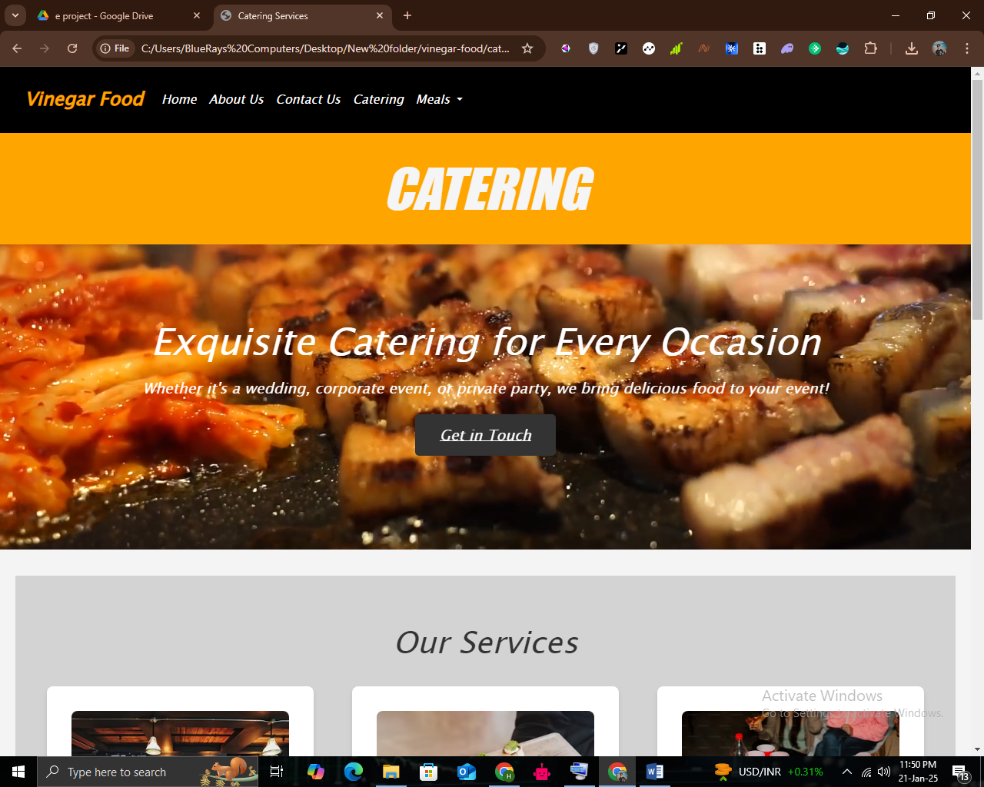

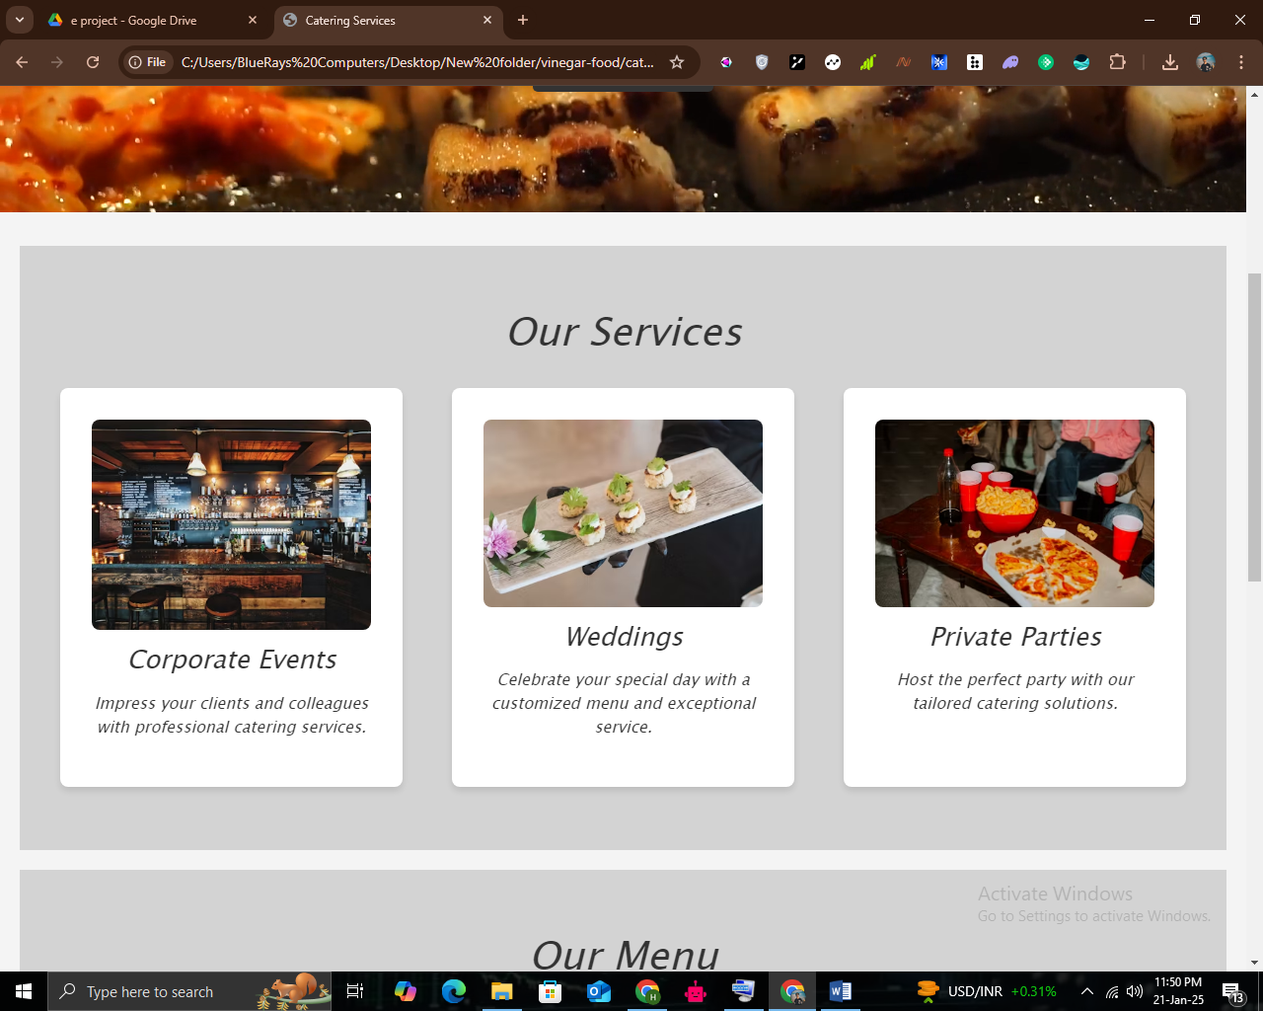

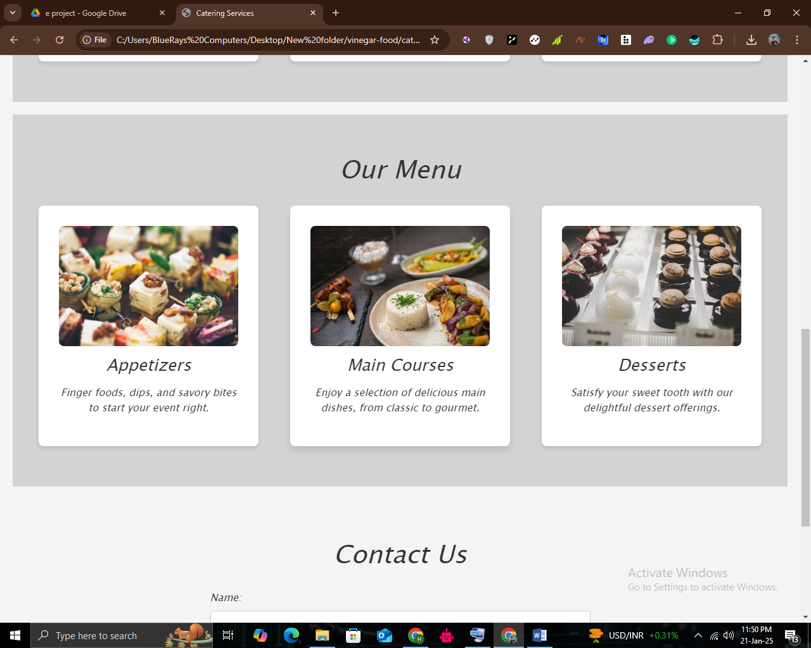

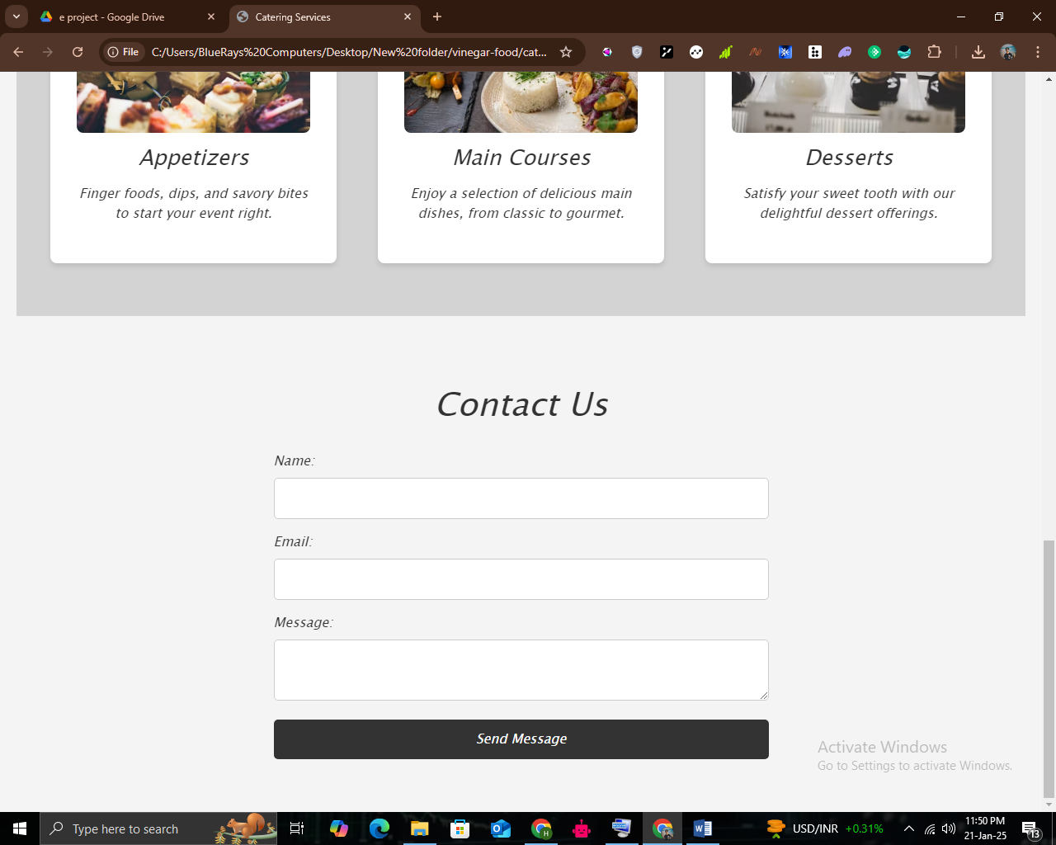

LUNCH: (lunch.html)

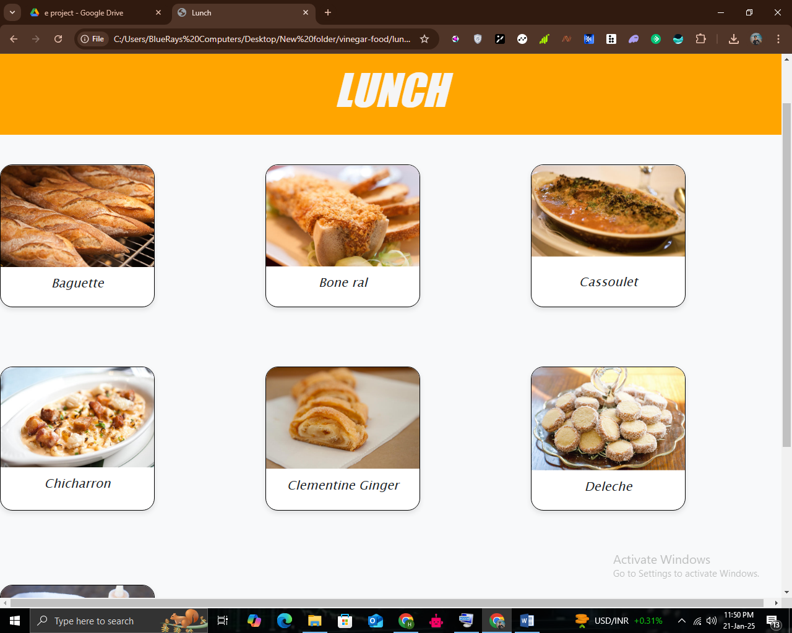

DESSERT: (dessert.html)

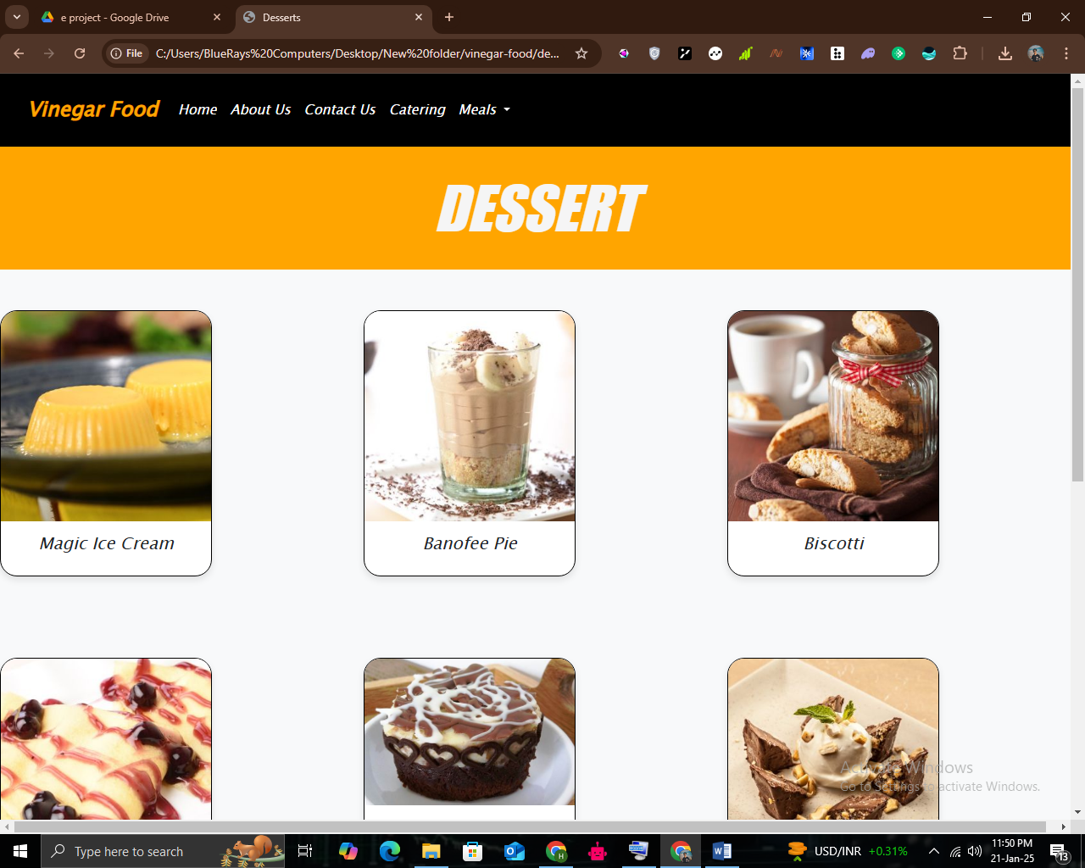

SNACK: (snack.html)

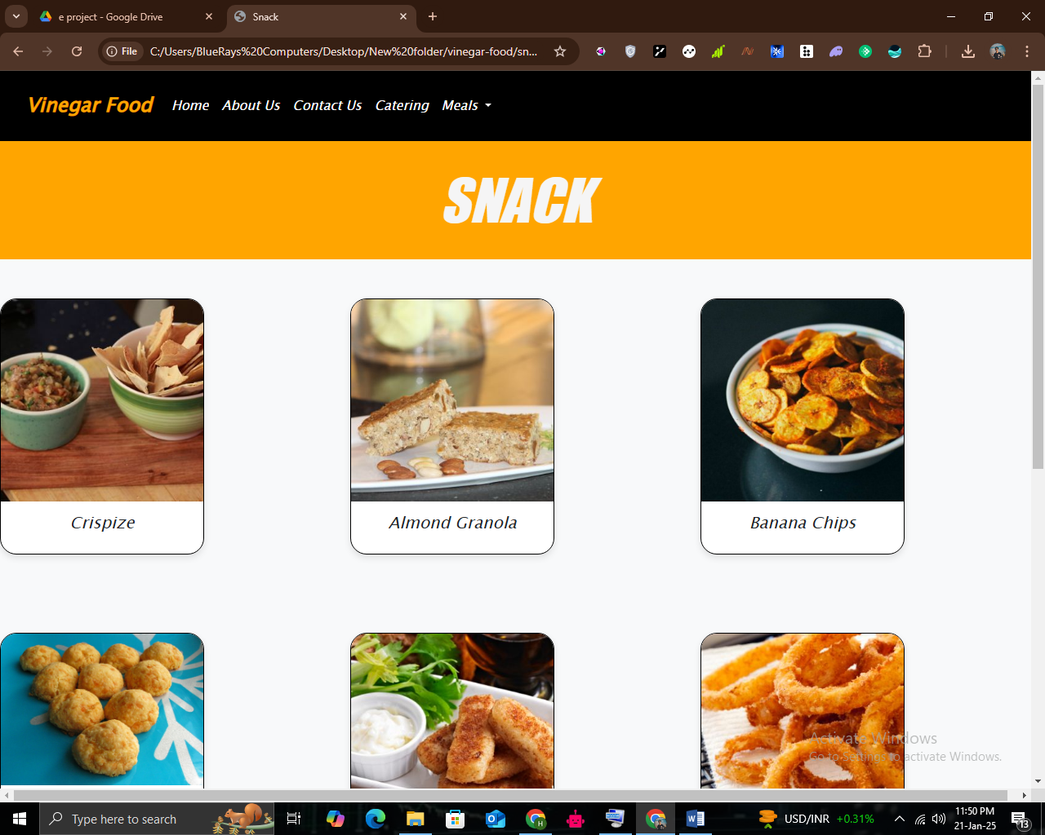

REGULAR: (regular.html)

